7 Level Telecommunications LLC
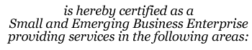
Installation and maintenance of communications to
This Certification is valid beginning 2/13/2009 and supersedes any
registration or listing previously issued. At any time there is a change in ownership
or control of the firm, notification must be made immediately to the Division of Small
and Emerging Business Development.
2/13/2019
2/13/2009
6366
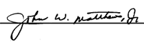
John W. Matthews, Jr., Executive Director
Small Business Services

